**Page 92: # 16, 22, 30**

Note, I will be using the following set notation with the assumption that *f(x)* is defined in each question:



Note, I may have used *a* and *b* interchangeably in exp. functions.

**Problem 16:**





**Problem 22:**





**Problem 30:**

(a) 

(b).



Graph

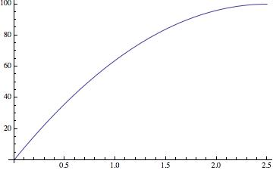

**Page 112: # 16, 26.**

**Problem 16:**

**(i) **

**(ii) **

**(iii) **

**(iv) **

**(v) **

**(vi) **

Towns that are growing: {i, ii, iv}

Towns decaying: {iii, v, vi}.

Fastest growth: iv, 18.5%

Fastest decay: v, 22%

Largest initial population: iii, 2500

Smallest initial population: 600

**Problem 26:**

1. 25
2. 15%
3. 4.92186010851807



**Page 120: # 22, 34, 36.**

**Problem 22:**



**Problem 34:**

a)



b)



c)

Linear: 

Exponential:



**Problem 36:**



**Page 127: # 4, 18, 40**

**Problem 4:**

f(x) is decreasing the fastest

h(x) is decreasing the slowest

g(x) is in the middle.

**Problem 18:**

**a)**



**b)**



**Problem 40**

a) 

b) The function S(t) seems to fit the data well, however there may be some floating point imprecisions.

c) 42.335759%

d) The sales in the year 2010 should be approximately 4710.725252 million.